**CRM APPLICATION FOR JEWEL MANAGEMENT – (DEVELOPER)**

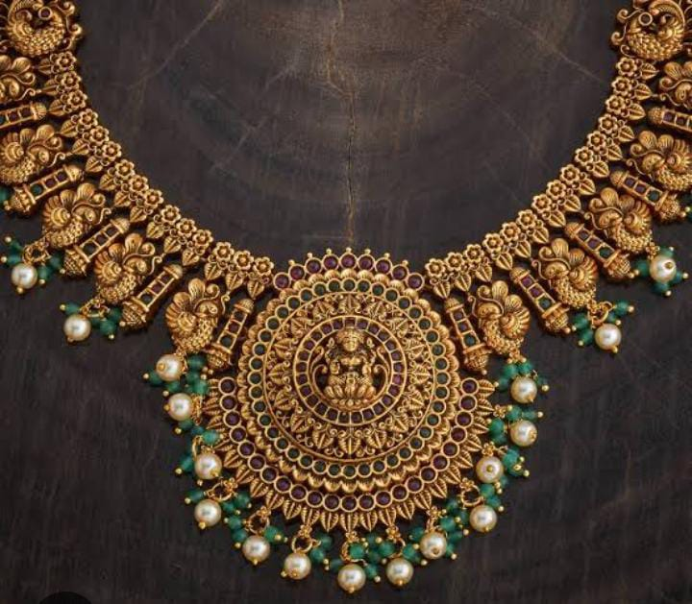

COLLEGE NAME: L.R.G GOVT ARTS COLLEGE FOR WOMEN-TIRUPUR

COLLEGE CODE: bru07

**TEAM ID**

TEAM MEMBERS:

Team Leader Name: SURUTHI T

Email: suruthisuruthi682005@gmail.com

Team member 1: DHANUSRI I

Email: dhanudhanu2921@gmail.com

Team member 2: SUGUNA R

Email: sugunasuguna55906@gmail.com

Team member 3: RAMYA S

Email: ramyabharani098@gmail.com

**INTRODUCTION**

Project overview

CRM application for a jewellery management project aims to improve customer relationships, streamline sales and marketing processes, and centralize customer data to foster growth. Include managing customer profiles, tracking purchase history, enabling personalized communication, and analysing customer behaviour to offer purpose tailored recommendations and conduct targeted marketing campaigns. By centralizing information and automating tasks, a jewellery CRM enhances customer satisfaction, drives loyalty, and provides valuable insights for better business decisions and increased sales.

PURPOSE

The main purpose of the project is to: Gathers data on preferences, buying history, and behaviour to personalize outreach and improve satisfaction. Tracks inquiries and sales leads, automates follow- ups, and enables personalized marketing campaigns based on customer data. Analyses sales data to identify top- selling and slow- moving items, helping to optimize stock levels. Streamlines communication, handles customer feedback, and provides personalized support by documenting all interactions.

DEVELOPMENT PHASE

Creating Developer Account:

By this URL : <https://developer.salesforce.com/signup>

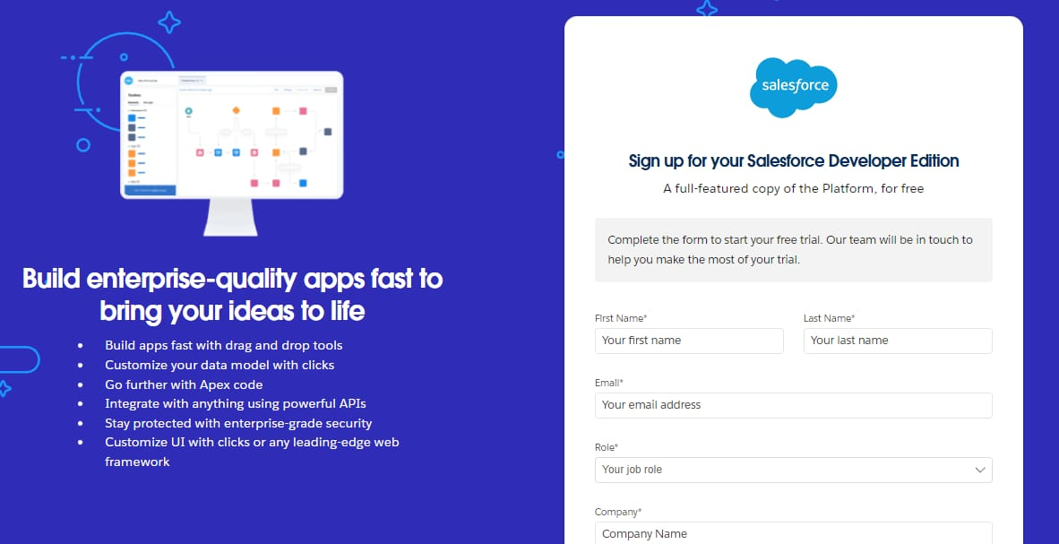

Account Activation

Then you will redirect to your salesforce setup page.

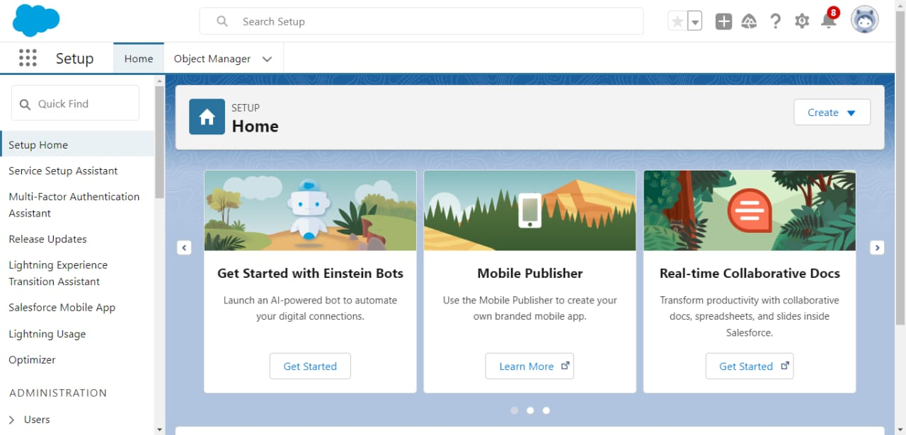

Create Jewel Customer Object

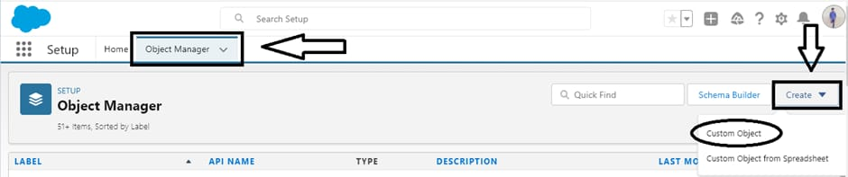

Create Item Object

The purpose of creating a Item object is to manage the inventory of gold and silver items.

To create an object:

1. From the setup page   >> Click on Object Manager >> Click on Create >> Click on Custom Object.
2. Enter the label name >> Item
3. Plural label name >> Items
4. Enter Record Name Label and Format

* Record Name >> Item Id
* Data Type >> Auto Number
* Display Format >> Item-{00}
* Starting Number >> 1

1. Click on Allow reports.
2. Allow search >> Save.

**Note: Create 3 more objects with label names as Customer Order, Price, Billing**

**(**Use “Auto Number” as a data type for Customer Order, Price, Billing).

Tabs

Creating a Custom Tab

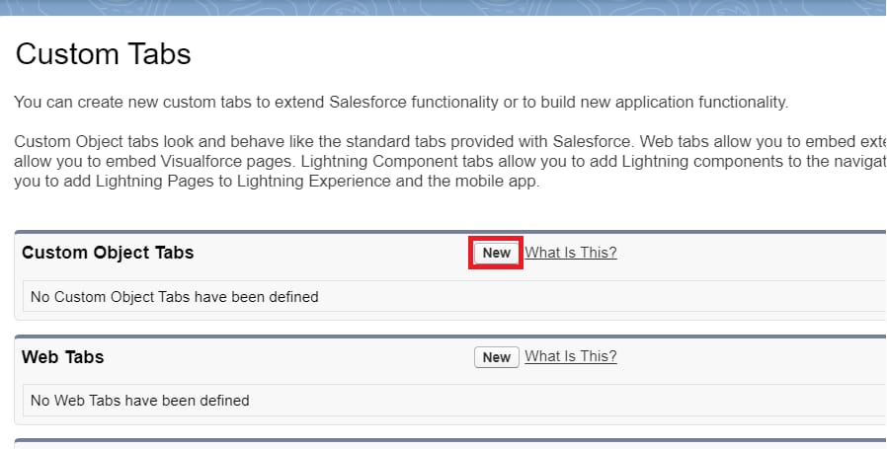

Select Object (Jewel Customer) >> Select any tab style >> Next (Add to profiles page) keep it as default >> Next (Add to Custom App) keep it as default >> Save.

To create a Tab:(Item)

**The Lightning App**

Create a Lightning App

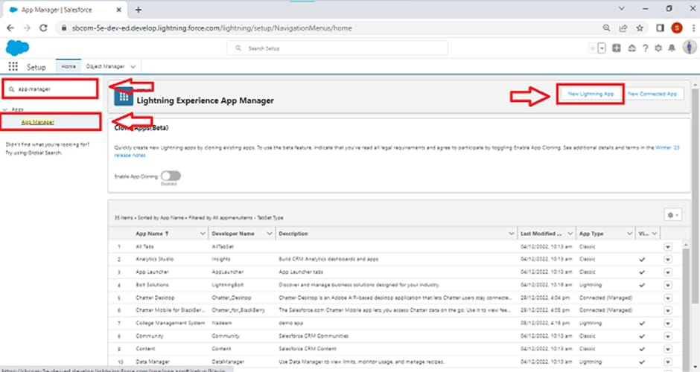

It is created jewellery inventory system

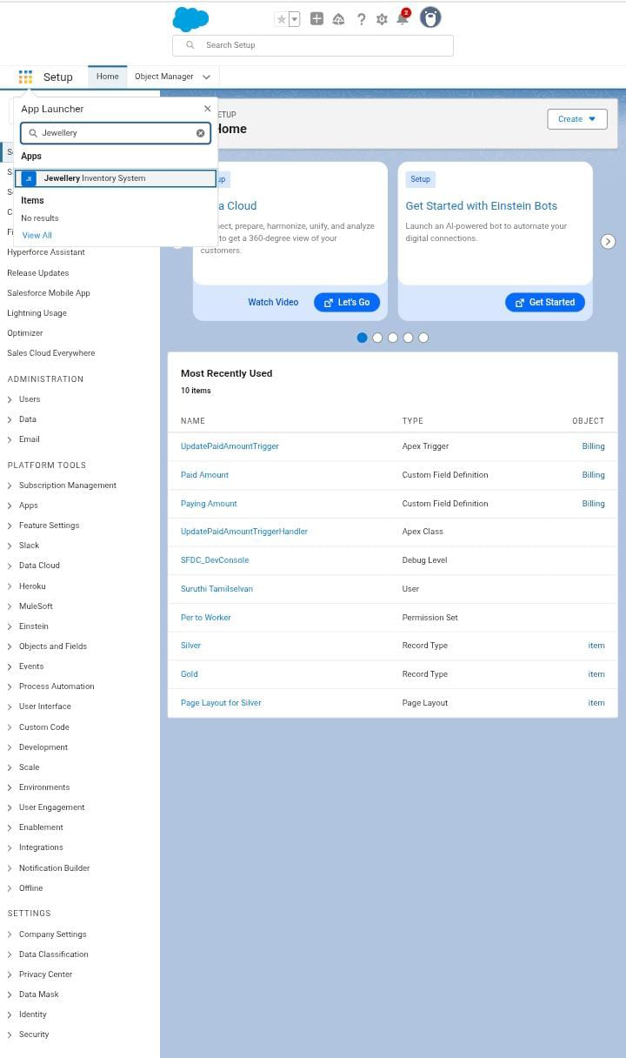

**Fields**

Creating Lookup Relationship

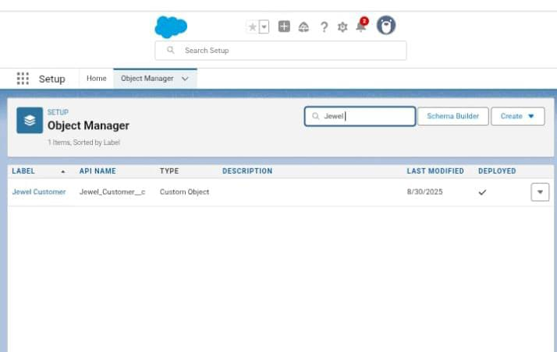

Creating a Master-Detail Relationship

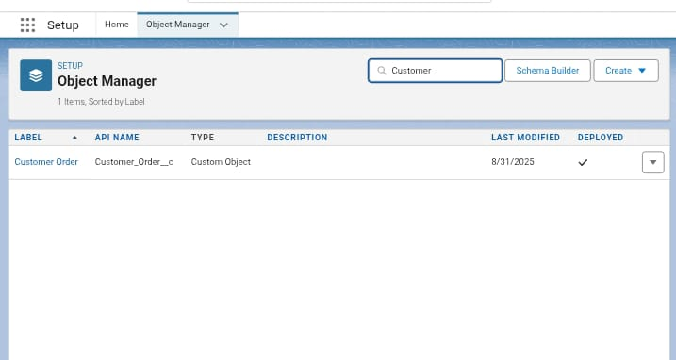

Creating Text Field in Jewel Customer Object

Creating the Phone field in object Jewel Customer

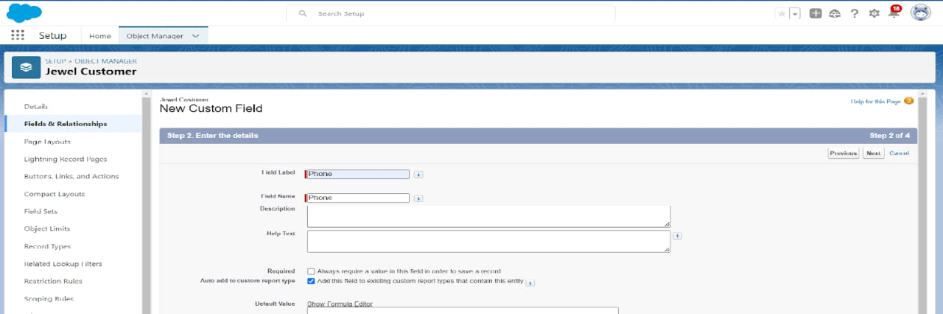

Field Name will be auto populated, and click on Next >> Next >> Save & new.

Creating the Email field in object Jewel Customer

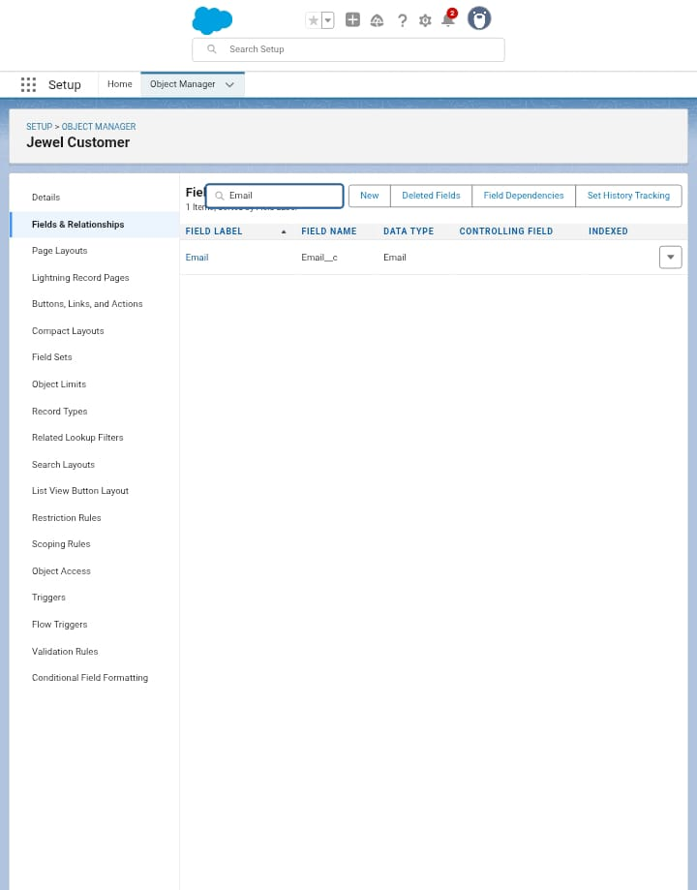

Field Name will be auto populated, and click on Next >> Next >> Save

Creating the number field in Item object

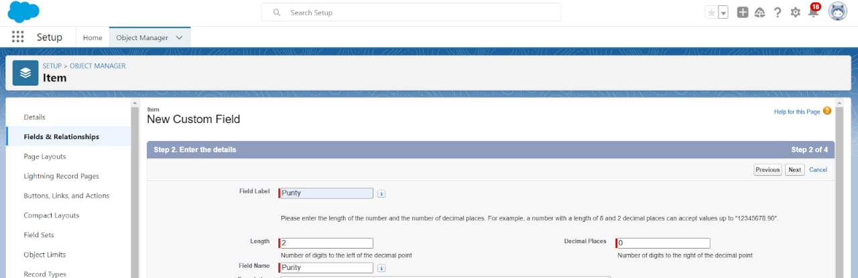

Field Name will be auto populated, and click on Next >> Next >> Save.

Creating Picklist Field in Item Object

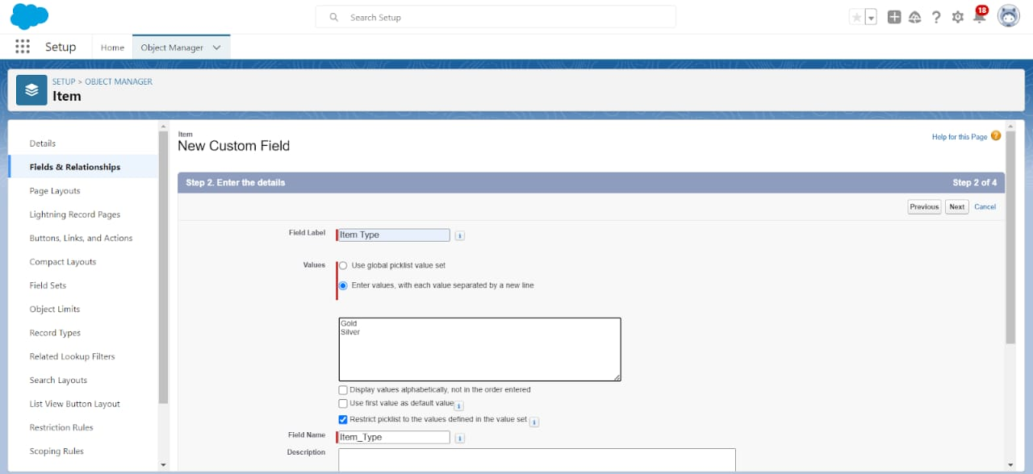

Click Next? Next? Next? Save .

Creating Currency Field in Price Object



Creating Remaining Fields in Objects Jewel Customer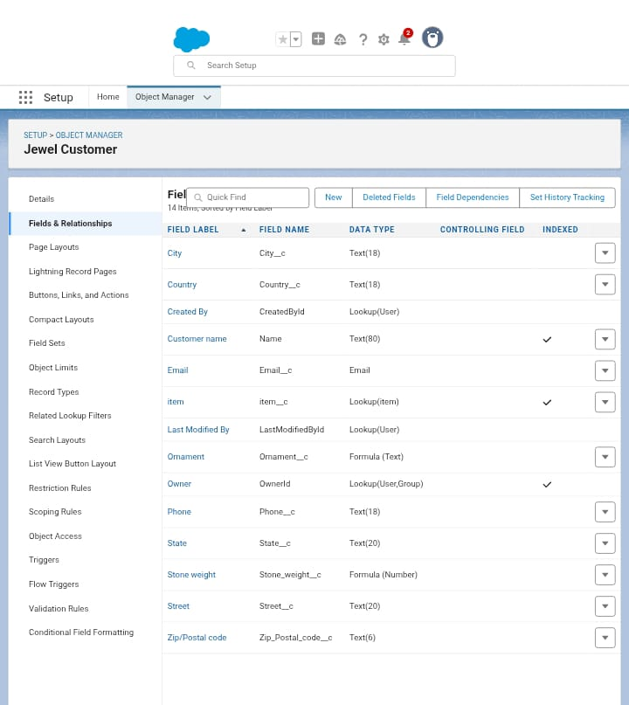

Price

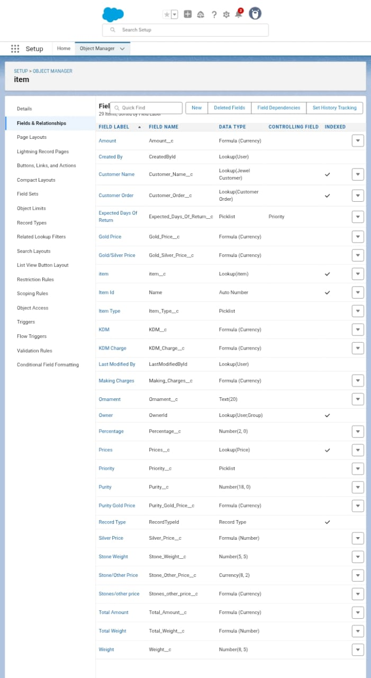

Customer Order:

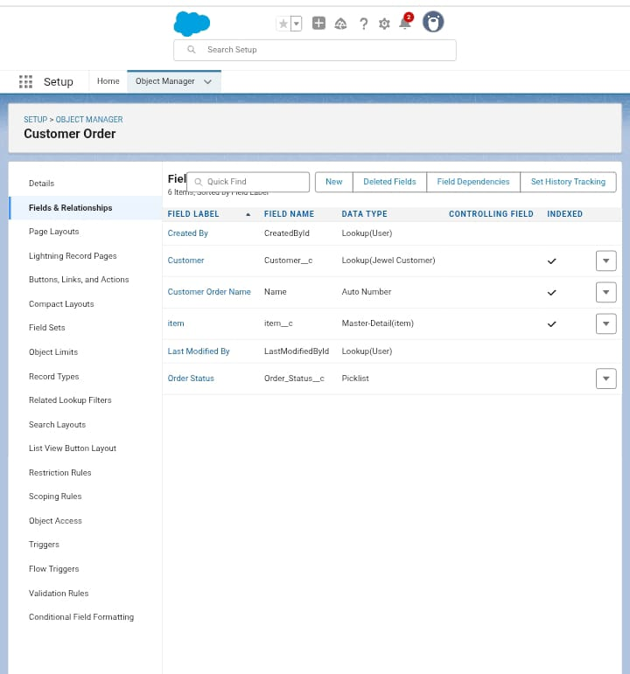

Billing

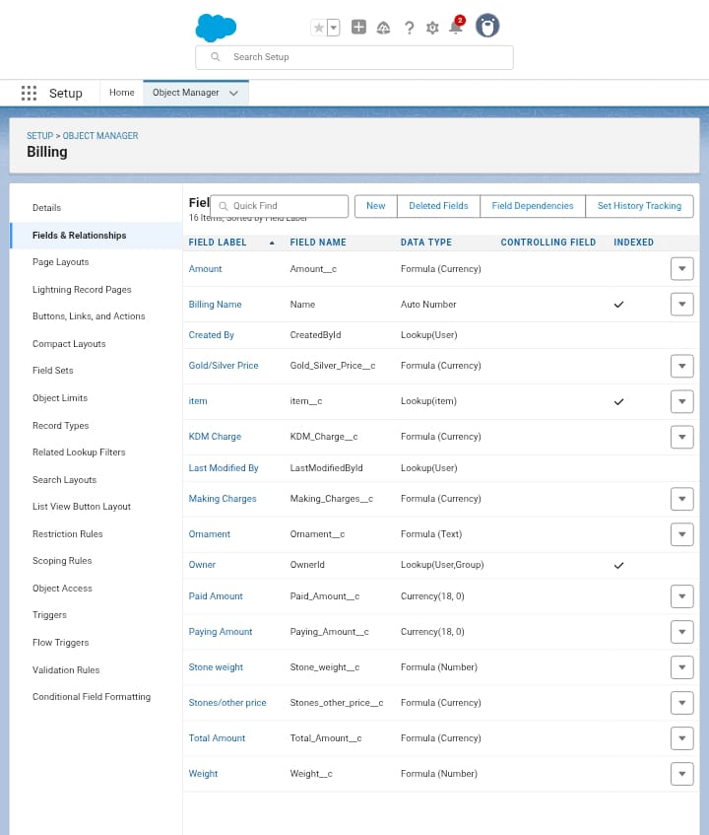

Schema Builder

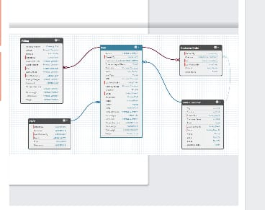

Then will you create **the Field Dependencies &the validation rule.**

PROFILE

Gold Smith Profile

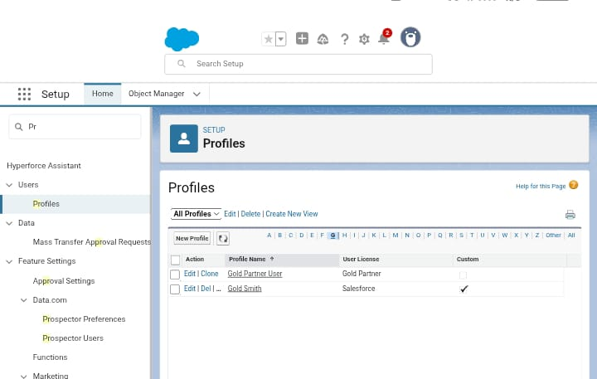

Worker Profile

Roles

CreatingGoldSmithRole

Give Label as “Gold Smith” and Role name gets auto populated. Check to whom this role (Gold Smith) reports. Then click on Save.

Create one more role as Woker which reports to Gold Smith:

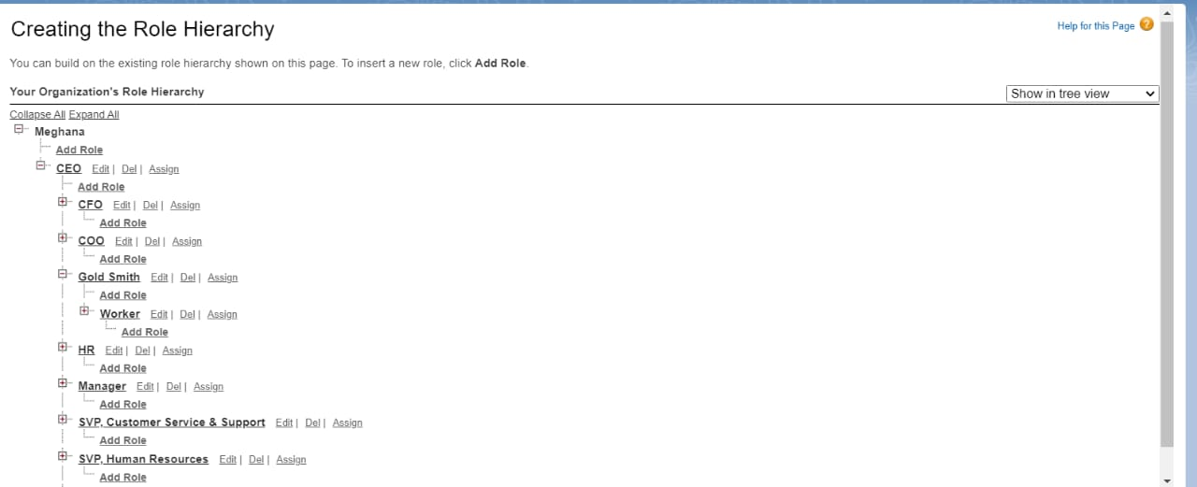

Users:

CreateUser

You create user for the instruction

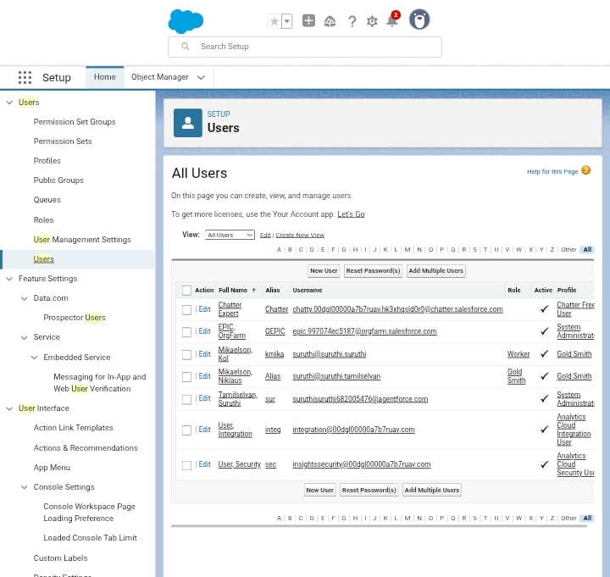

Page layouts

To Create a Gold Page layout:

Go to Setup >> Click on Object Manager >> Search for the object (Item) >> From drop down click on Edit.

Click on Page layout >> Click on New.

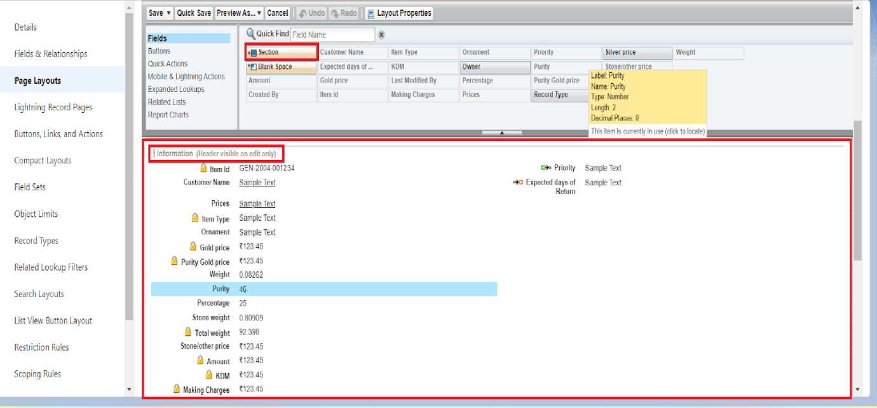

Click Save.

**

Record Types

To create a Record Type

**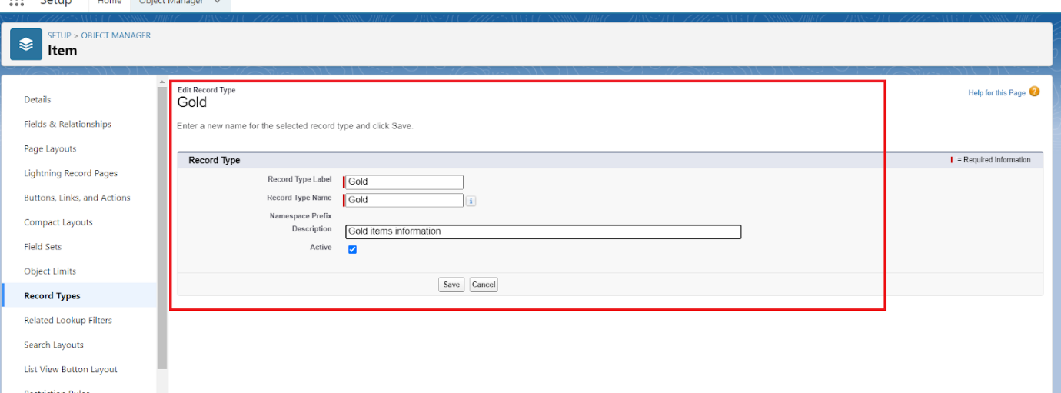  
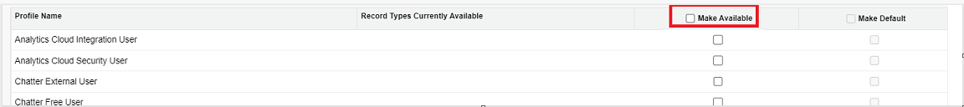**

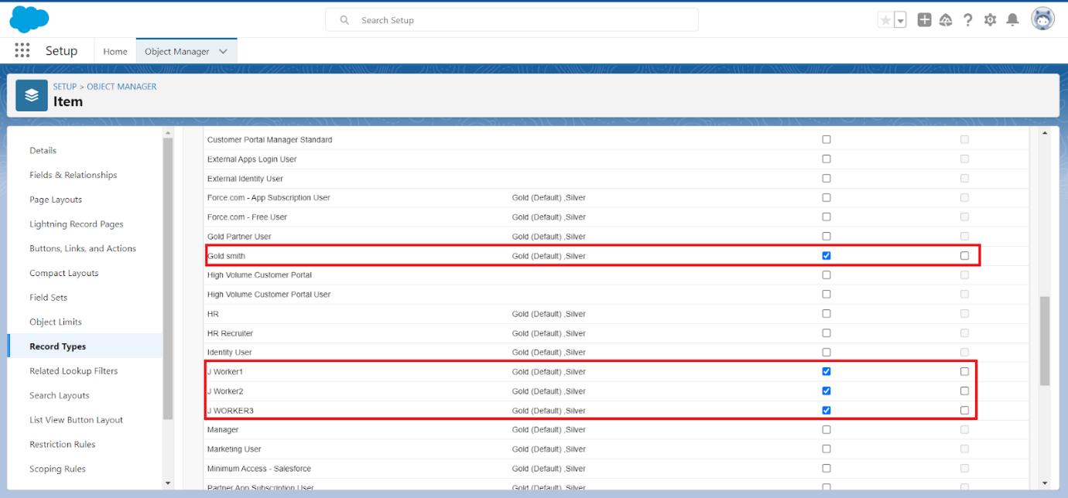

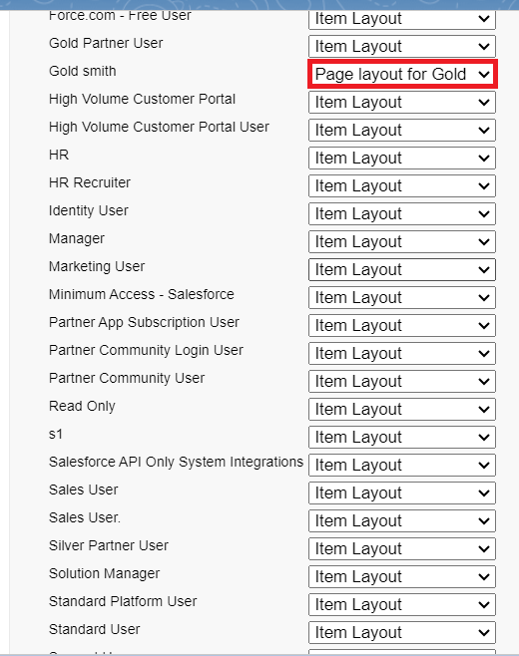

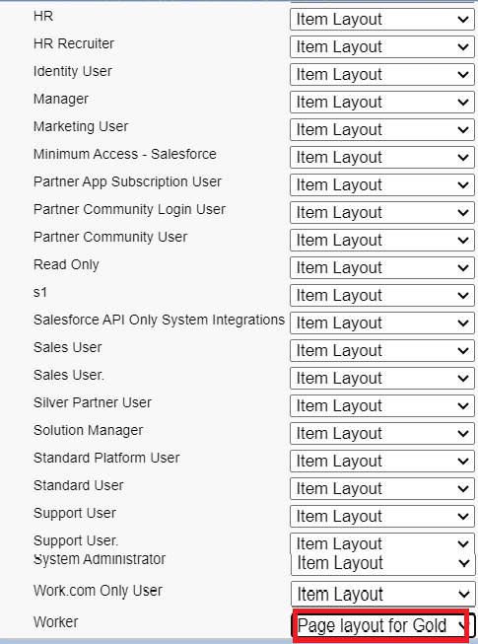

Permission sets

Creating permission set Per to Worker

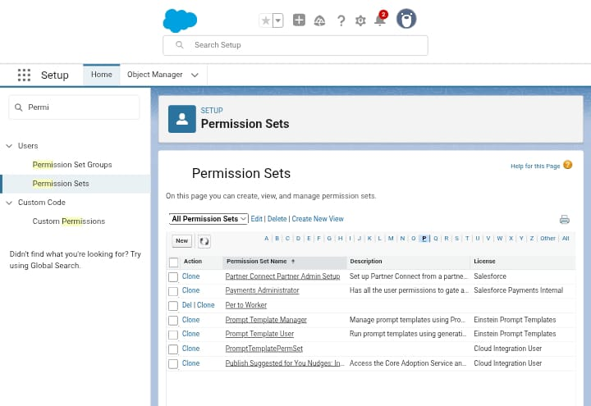

Trigger:

Create a Trigger Handler class

Trigger handler:

CODE:

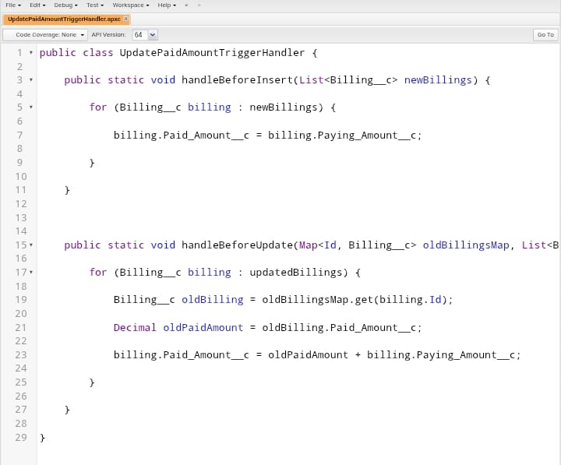

Create the trigger

CODE:

User Adoption:

Create a Record (Jewel Customer):

you follow the instruction

Create a Record (Jewel Customer)

Fill the Details and click on Save.

Delete a Record (Jewel Customer):

Jewel Customer:

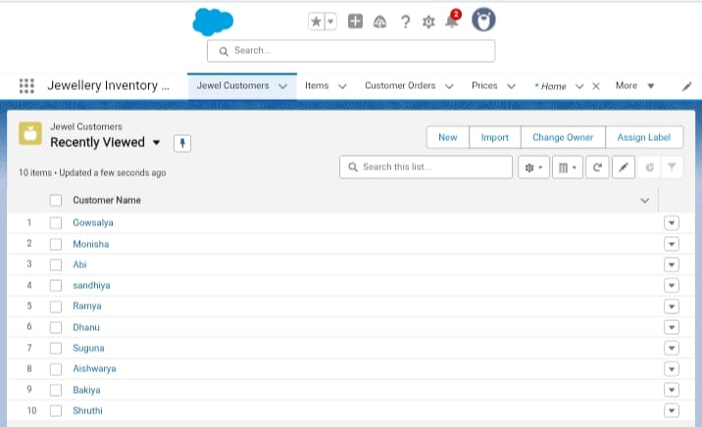Item

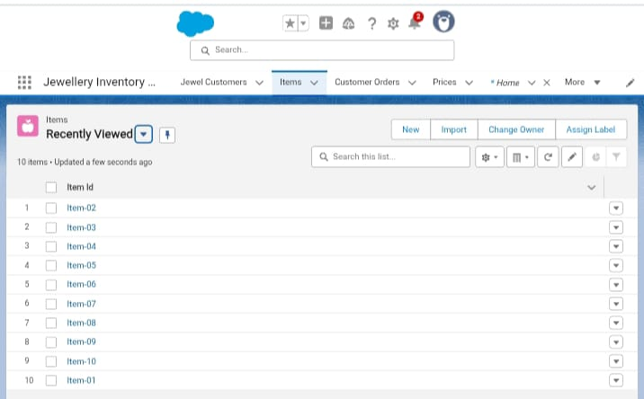

Customer Order:

Price

Billing

Reports

Dashboards

Flows

Create a Flow:

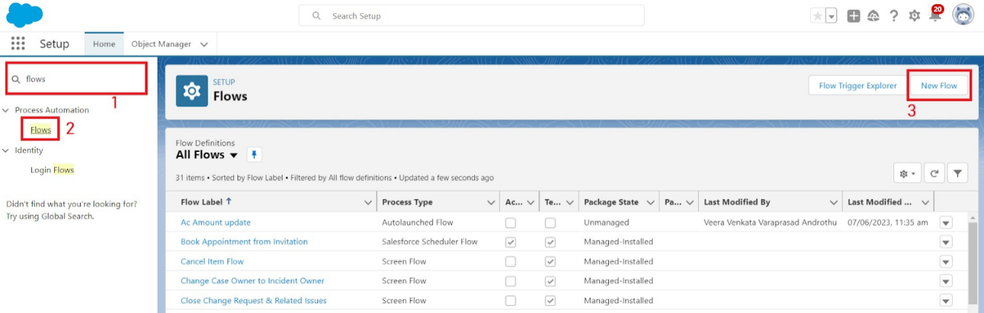

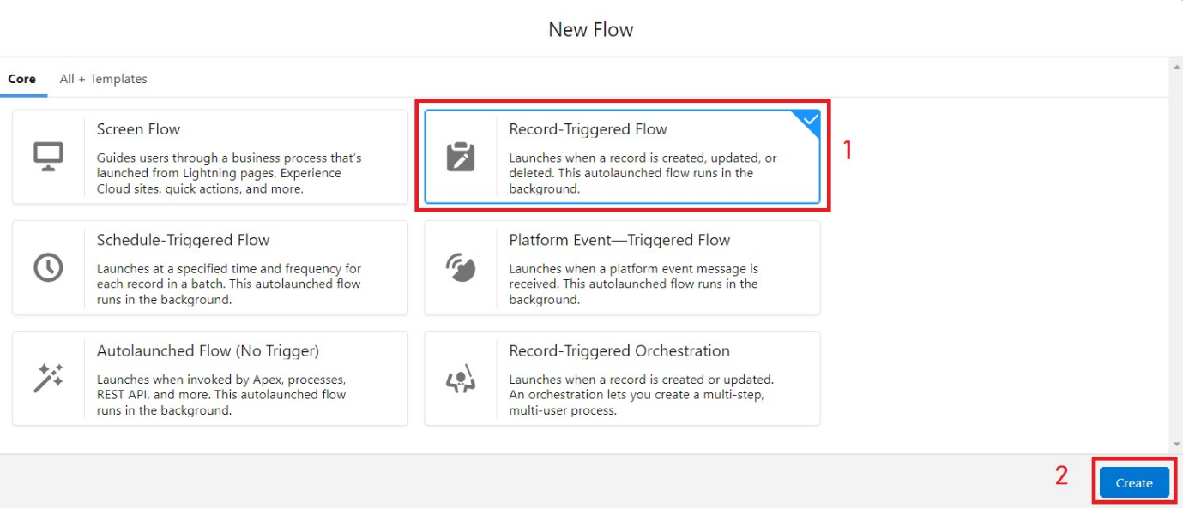

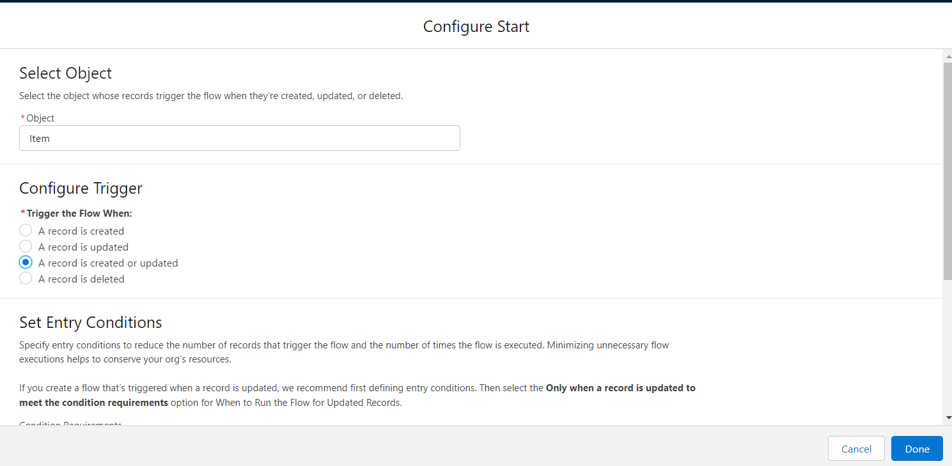

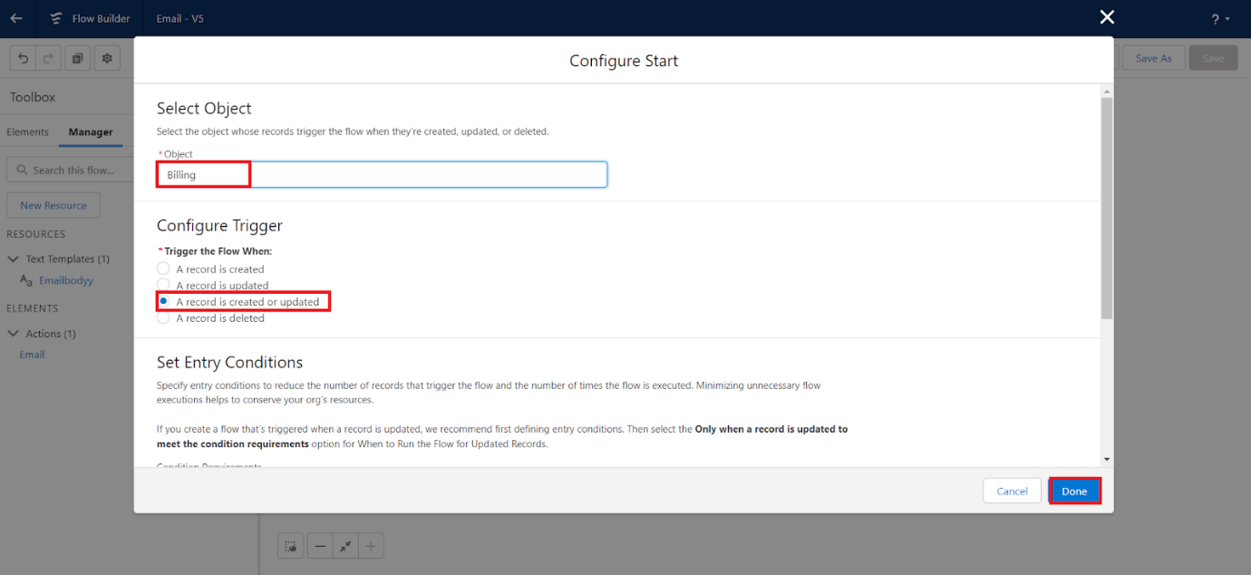

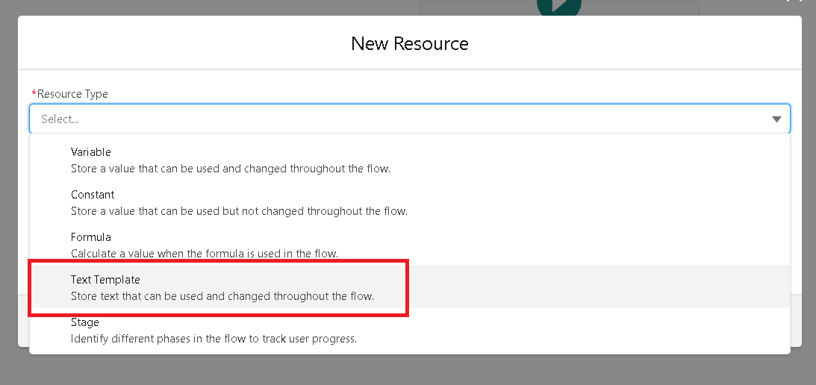

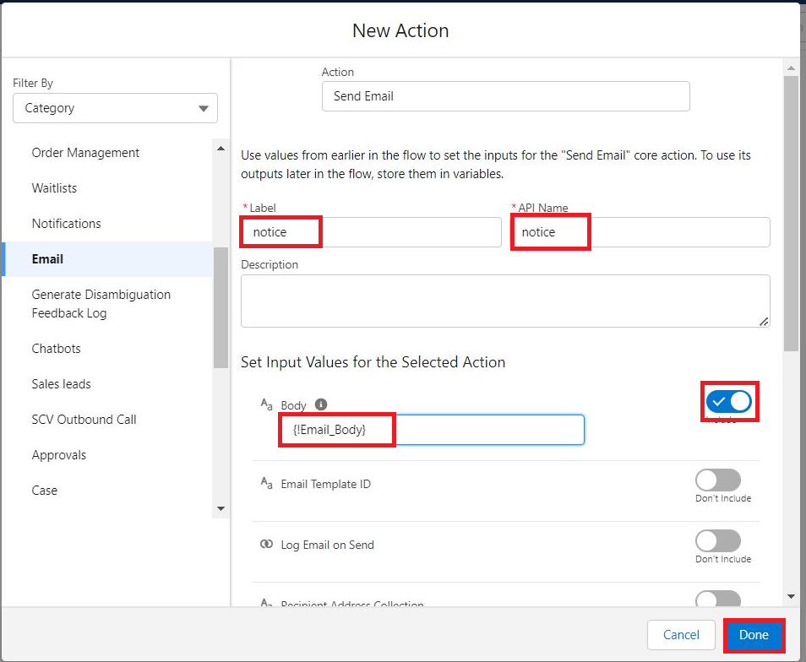

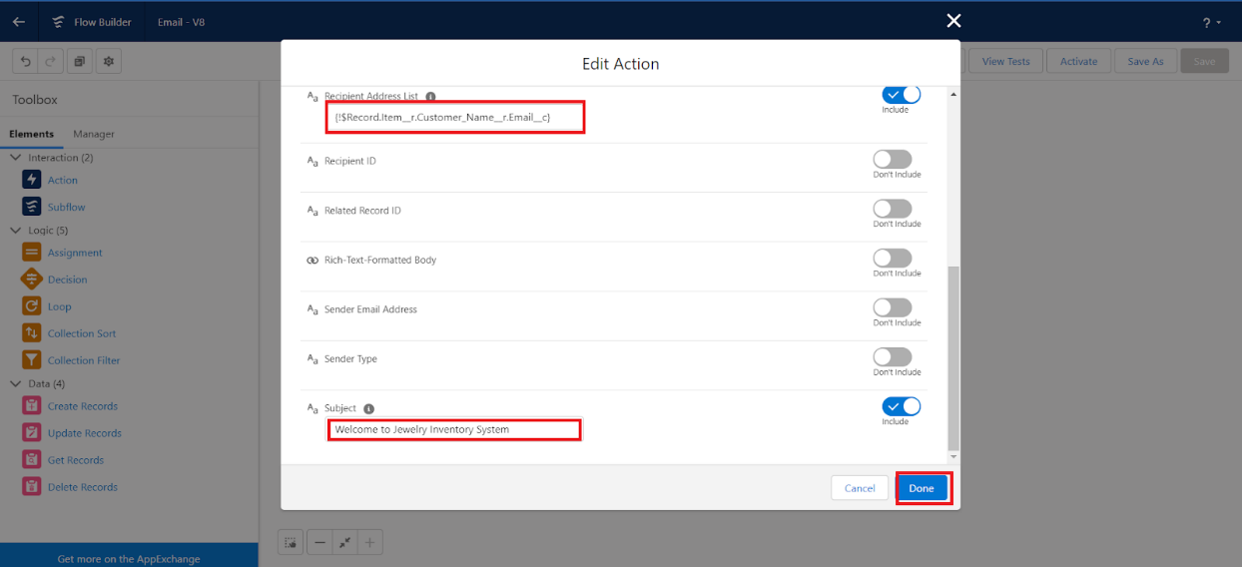

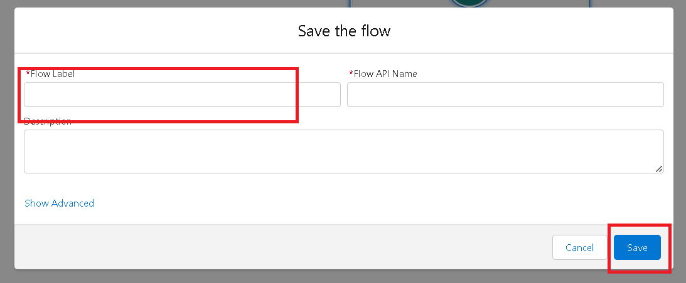

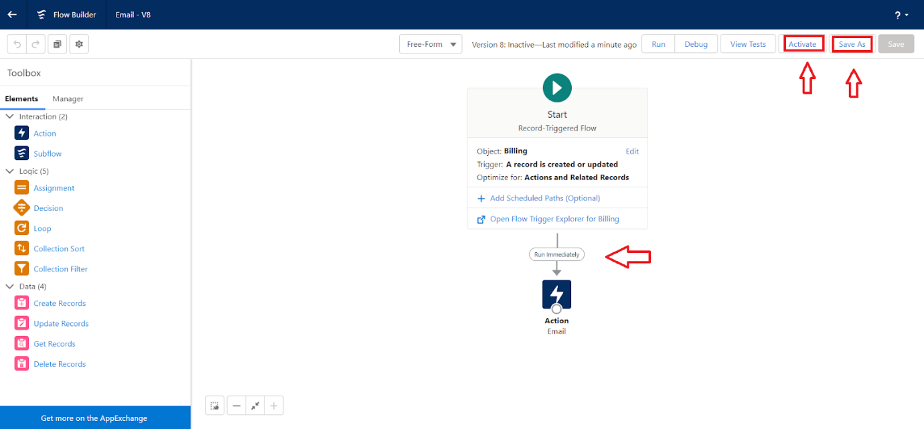

**CONCLUSION**

The CRM APPLICATION FOR JEWEL MANAGEMENT- (DEVELOPER) successfully streamlines the operations of leasing through a structured, automated Salesforce application. It improves efficiency, communication, and data accuracy for both admins and tenants.